1: Download terraform
To install Terraform, First Download the Terraform Cli Utility for windows from terraforms official website https://www.terraform.io/downloads.html
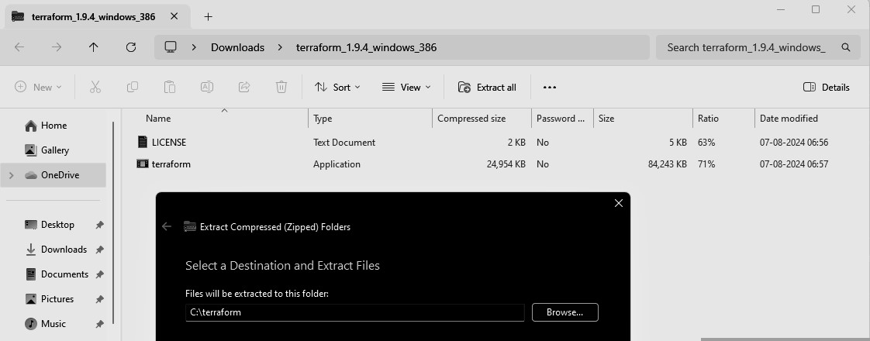
Select the Operating System Windows followed by either 32bit or 64 bit based on your OS type.
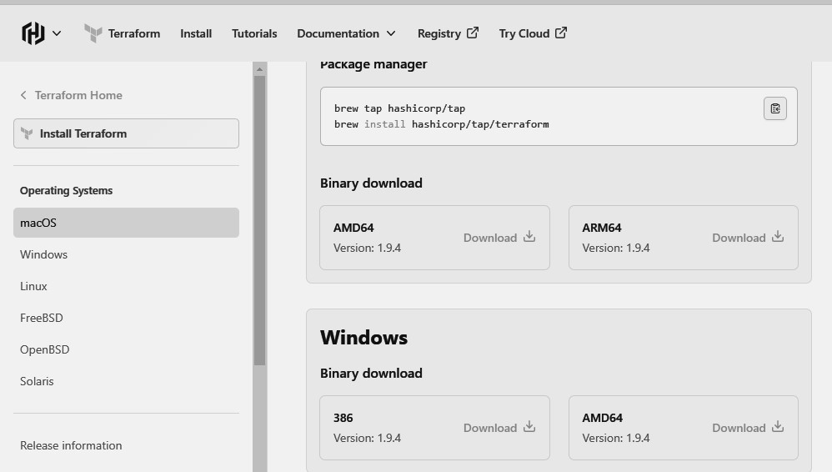
Step 2: Extract the downloaded setup file Terraform.exe in C:\Terraform directory
3: Set the System path for Terraform in Environment Variables
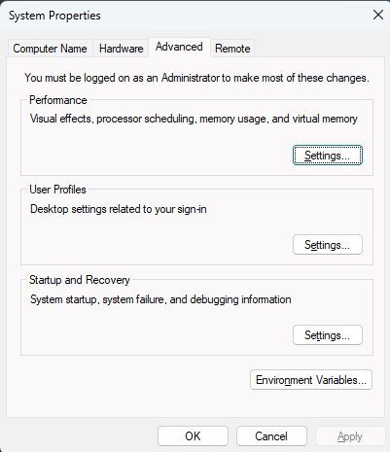
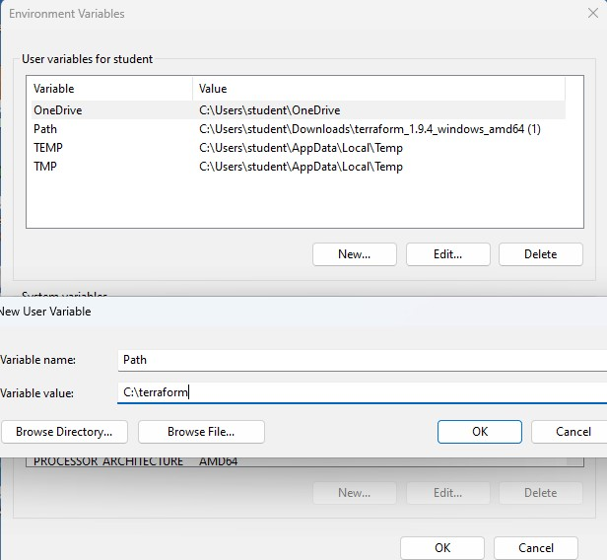
4: Open PowerShell with Admin Access
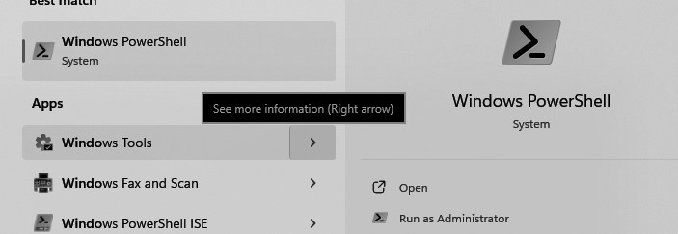
Step 5 : Open Terraform in PowerShell and check its functionality
